“game on” Field day 2019
“Game On” is our video game themed field day and it is right around the corner on May 17th! If you would like to order a shirt(s) please fill out the form below and return it to Coach Witten or Coach Butler by May 1. The shirt will be white, short-sleeve and on 100% cotton fabric. This year we will also have the Kona Ice truck selling sno cones at field day, so your child will have the opportunity to buy one during their field day time. With a shirt purchase, you will get a free lanyard and resealable pouch to hold sno cone money and/or tokens.
VOLUNTEERS NEEDED!!
We will need many volunteers to help make field day a success. If you can help during any of these shifts, please see the TVE website or click on the links below by May 10th. The K-2 class and 3-5 class that gets the most parent volunteers gets an extra 2 hours of field day! Thank you!
Field Day Volunteer Link can be found at www.teravistape.weebly.com
Round Rock ISD Volunteer Sign-Up/Background Check form (also on the TVE website): https://roundrockisd.org/departments/community-partnerships/volunteer-application/
$10 for SHIRTS – DUE MAY 1ST!!
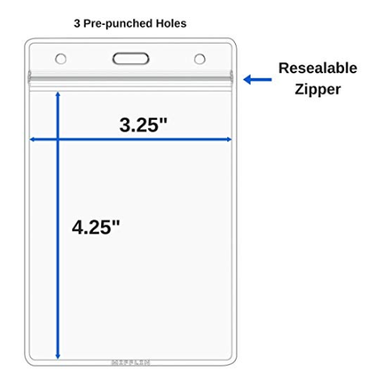
Shirt design will be on a white 100% cotton shirt
A resealable money/token holder and lanyard comes FREE with your shirt order! (picture is not to scale)

------------------------------------------------------------------Please Detach Here--------------------------------------------------------------------

Student Name: ____________________________ Homeroom Teacher: ________________ Grade: ___
Please select sizes ($10 PER SHIRT – ANYBODY CAN ORDER!):
($10) YOUTH SMALL: ___ ($10) YOUTH MEDIUM: ___ ($10) YOUTH LARGE: ___
($10) ADULT SMALL: ___ ($10) ADULT MEDIUM: ___ ($10) ADULT LARGE: ___ ($10) ADULT XL: ___
($10) ADULT 2XL: ___
Make checks payable to “Teravista Elementary” and please include driver’s license number: TOTAL COST: $ _______

